Chapter 3, Problem 31.

Find the node voltages for the circuit in Fig. 3.80.

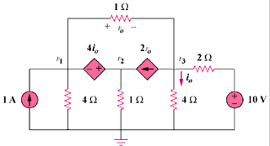

Figure 3.80
For Prob. 3.31.

